Abstract
Including more features in the model makes the model more complex, and the model may be overfitting the data. Some features can be the noise and potentially damage the model. By removing those unimportant features, the model may generalize better.

Correlation Analysis
Correlation analysis is a statistical method used to evaluate the strength of relationship between two quantitative variables. A high correlation means that two or more variables have a strong relationship with each other, while a weak correlation means that the variables are hardly related. In other words, it is the process of studying the strength of that relationship with available statistical data. This technique is strictly connected to the linear regression analysis that is a statistical approach for modeling the association between a dependent variable, called response, and one or more explanatory or independent variables.

Interpreting Results
Typically, the best way to gain a generalised but more immediate interpretation of the results of a set of data, is to visualise it on a scatter graph such as these:

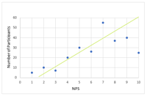
Positive Correlation
Any score from +0.5 to +1 indicates a very strong positive correlation, which means that they both increase at the same time. The line of best fit, or the trend line, is places to best represent the data on the graph. In this case, it is following the data points upwards to indicate the positive correlation.

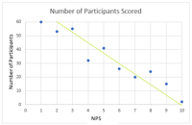
Negative Correlation
Any score from -0.5 to -1 indicate a strong negative correlation, which means that as one variable increases, the other decreases proportionally. The line of best fit can be seen here to indicate the negative correlation. In these cases it will slope downwards from the point of origin.

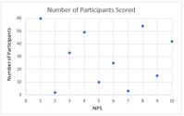
No Correlation
Very simply, a score of 0 indicates that there is no correlation, or relationship, between the two variables.The larger the sample size, the more accurate the result. No matter which formula is used, this fact will stand true for all. The more data there is in putted into the formula, the more accurate the end result will be.

Correlation Analysis

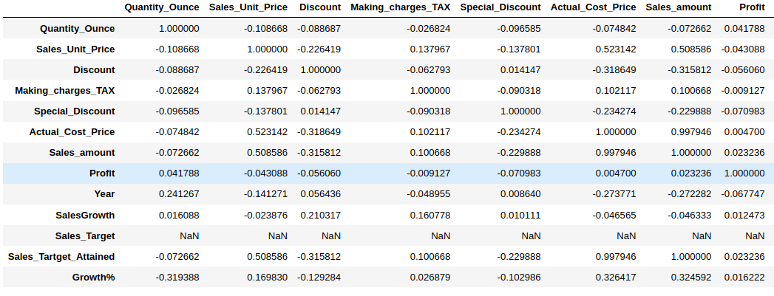

From the above correlation matrix, we can say that the variables Making_Charges+TAX , Sales_Unit_Price and Actual_Cost_Price are the most dependent among other variables.

Dependency wise order:
1. Actual Cost Price – 0.9979
2. Sales Unit Price – 0.5231
3. Making Charges+TAX - 0.1021

Regression Model

In statistical modeling, regression analysis is a set of statistical processes for estimating the relationships between a dependent variable (often called the 'outcome variable') and one or more independent variables (often called 'predictors', 'covariates', or 'features'). The most common form of regression analysis is linear regression, in which a researcher finds the line (or a more complex linear combination) that most closely fits the data according to a specific mathematical criterion.

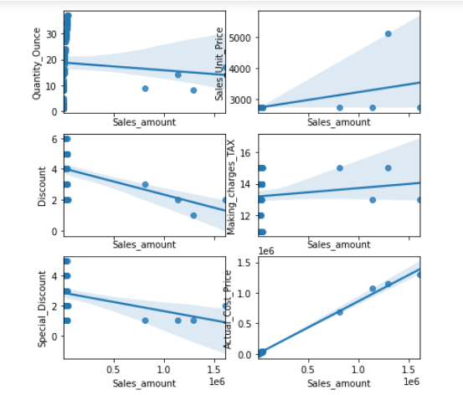
With the application of regression model our above assumption based on correlation analysis is confirmed from the avbove graphs.
Dependency wise order:
1. Actual Cost Price
2. Sales Unit Price
3. Making Charges+TAX

Univariate Feature Selection

Univariate feature selection works by selecting the best features based on univariate statistical tests. We compare each feature to the target variable, to see whether there is any statistically significant relationship between them. It is also called analysis of variance (ANOVA). When we analyze the relationship between one feature and the target variable, we ignore the other features. That is why it is called ‘univariate’. Each feature has its test score.
Finally, all the test scores are compared, and the features with top scores will be selected.

Recursive Feature Elimination

Recursive feature elimination (RFE) is a feature selection method that fits a model and removes the weakest feature (or features) until the specified number of features is reached. Features are ranked by the model’s coef_ or feature_importances_ attributes, and by recursively eliminating a small number of features per loop, RFE attempts to eliminate dependencies and collinearity that may exist in the model.
RFE requires a specified number of features to keep, however it is often not known in advance how many features are valid. To find the optimal number of features cross-validation is used with RFE to score different feature subsets and select the best scoring collection of features. The RFECV visualizer plots the number of features in the model along with their cross-validated test score and variability and visualizes the selected number of features.

EXTRATREE CLASSIFIER

Extremely Randomized Trees Classifier(Extra Trees Classifier) is a type of ensemble learning technique which aggregates the results of multiple de-correlated decision trees collected in a “forest” to output it’s classification result. In concept, it is very similar to a Random Forest Classifier and only differs from it in the manner of construction of the decision trees in the forest.
Each Decision Tree in the Extra Trees Forest is constructed from the original training sample. Then, at each test node, Each tree is provided with a random sample of k features from the feature-set from which each decision tree must select the best feature to split the data based on some mathematical criteria (typically the Gini Index). This random sample of features leads to the creation of multiple de-correlated decision trees.
To perform feature selection using the above forest structure, during the construction of the forest, for each feature, the normalized total reduction in the mathematical criteria used in the decision of feature of split (Gini Index if the Gini Index is used in the construction of the forest) is computed. This value is called the Gini Importance of the feature. To perform feature selection, each feature is ordered in descending order according to the Gini Importance of each feature and the user selects the top k features according to his/her choice.

Building A Web Application For Finding Correlation

1. Introduction

Dash is a Python framework for building analytical web applications. It built on top of Flask, Plotly.js, React and React Js. It enables you to build dashboards using pure Python. Dash is open source, and its apps run on the web browser. In this tutorial, we introduce the reader to Dash fundamentals and assume that they have prior experience with Plotly.

2. Setting Up Environment

Using an IDE for writing/editing code. IDE can be Visual Studio, jetbrains-pycharm IDE, Jupyter, etc.
I have used jetbrains-pycharm IDE for writing/editing.

3. Installing Packages

Go to your python installed folder and on terminal write:
> pip install dash #installing dash frameworks
> pip install pandas #installing pandas libraries for applying algo.
> pip install plotly_express #installing plotly express for plotting graphs
> pip install sklearn #installing scikit learning packages for ML algorithms
gisticRegression

4. Importing Packages Into Our Code

import dash
mport dash_table
from dash.dependencies import Input, Output
import dash_html_components as html
import pandas as pd
import plotly.express as px
import dash_core_components as dcc
from sklearn.linear_model import LogisticRegression
from sklearn import preprocessing
from sklearn.feature_selection import RFE
from sklearn.feature_selection import SelectKBest
from sklearn.feature_selection import chi2

external_stylesheets = ['https://codepen.io/chriddyp/pen/bWLwgP.css']
#connecting to external stylesheet

sales = pd.read_csv('/home/ammy/Downloads/Book1.csv')
#importing data-set named as Book1.csv

deployment procedure: https://dash.plotly.com/deployment

5. Final Code

https://github.com/ammy20019/Dashboards_DASH_python/blob/master/Dashboards/correlation_dashboard.py

Deploying Test Application To Heroku

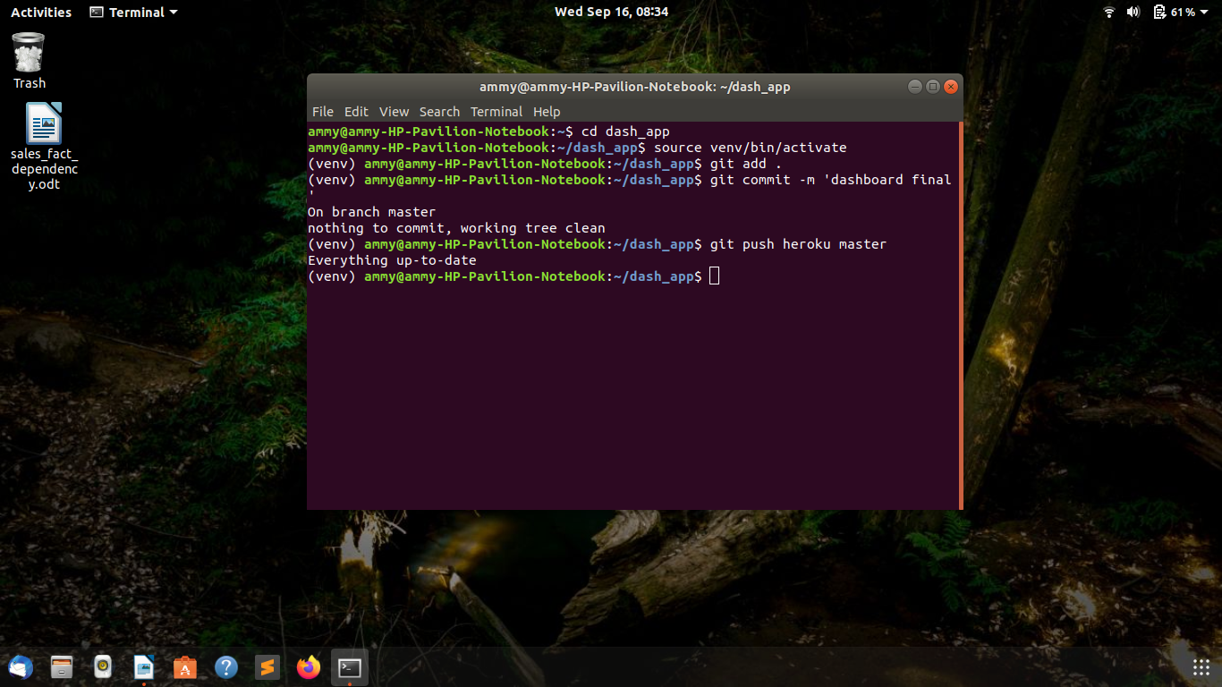

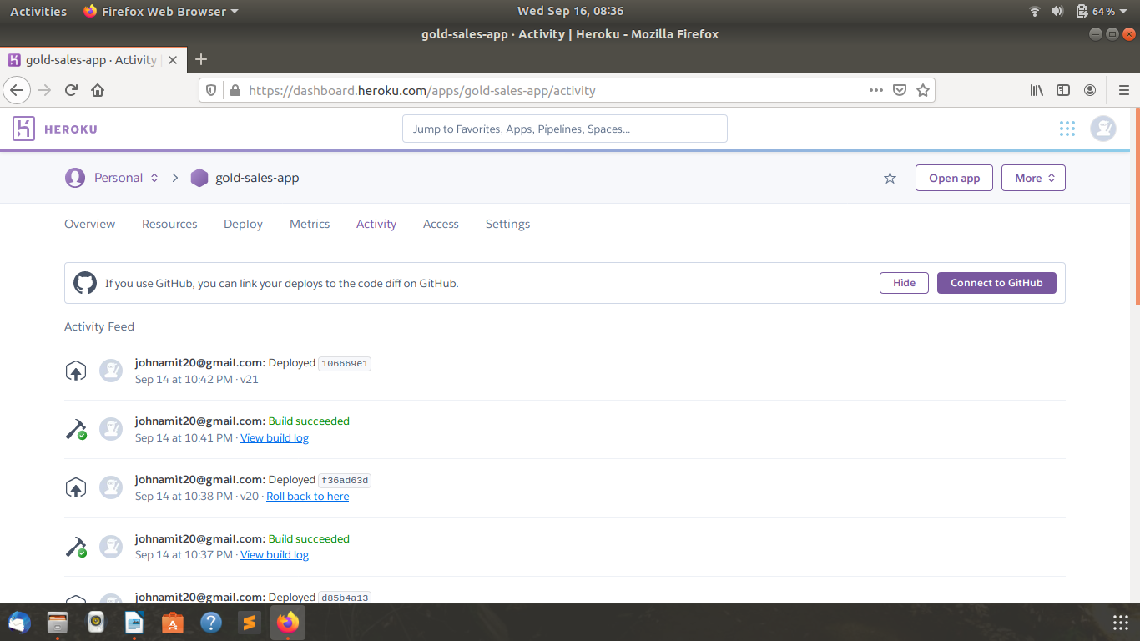

Final Dashboard Overview

